Project Design Phase
Solution Architecture

Date | 28 JAN 2026
Team ID | LTVIP2026TMIDS39173
Project Name | ToyCraft Tales: Tableau's vision into toy manufacturer data
Maximum Marks | 4 Marks

Solution Architecture:
Solution architecture is a complex process – with many sub-processes – that bridges the gap between business problems and technology solutions. Its goals are to:

- Find the best tech solution to solve existing business problems.
- Describe the structure, characteristics, behaviour, and other aspects of the software to project stakeholders.
- Define features, development phases, and solution requirements.
- Provide specifications according to which the solution is defined, managed, and delivered.

Example - Solution Architecture Diagram:

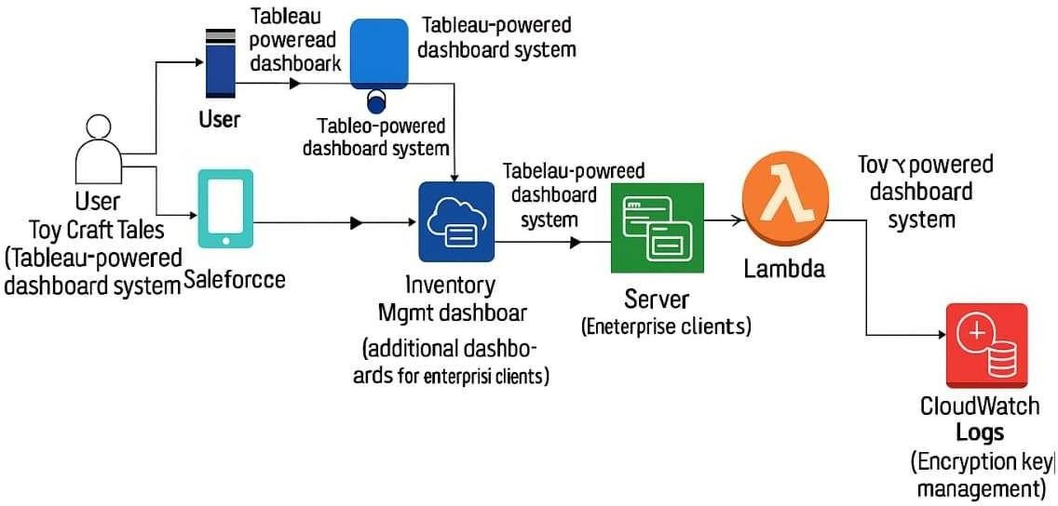

Figure 1: Architecture and data flow of the voice patient diary sample application

